A temporary h2 dataBase is created

Database navigation url: <http://localhost:8082/abcIgnite/h2-console>

Connection details:

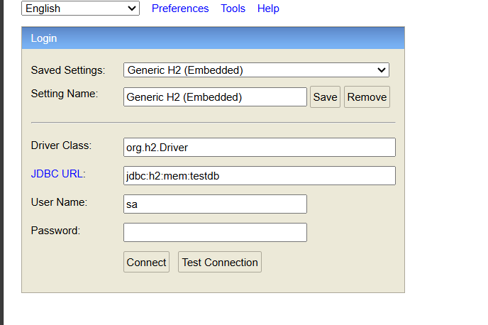

Note: you can connect to h2 db and view the data of tables